**Credit Card Management System**

**Brief description**

The proposed system is designed to change the existing system into more effective. It makes the customer easier to get a cash. The Card Management System could interact with an external Card Transaction System, thereby making the Card-related information maintained by the bank, up to date.

The purpose is to build a Card Management System which provides complete card processing, to meet the needs of full-fledged Credit card based ATM or Point of Sale network. Customer can apply for credit card and know his eligibility from his own place just by giving his personal details.

**Classes**

AdminLogin.Java

The admin password is “windows” to connect to the server.

AdminWorkspace.Java

Admin can see details of customers and total spending.

ItemPurchase.java

The form will show purchasing items to buy by customers.

MySqlConnect.java

Connection with the server is made.

Code Snippet

1. MysqlConnect.java

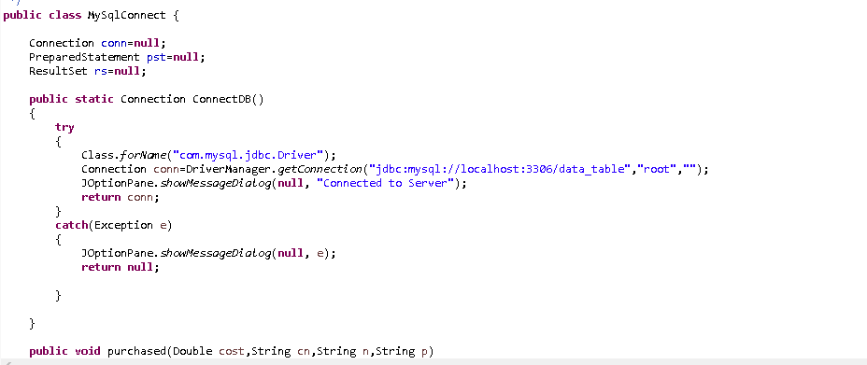

**Screenshots:**

**1.Start the server**

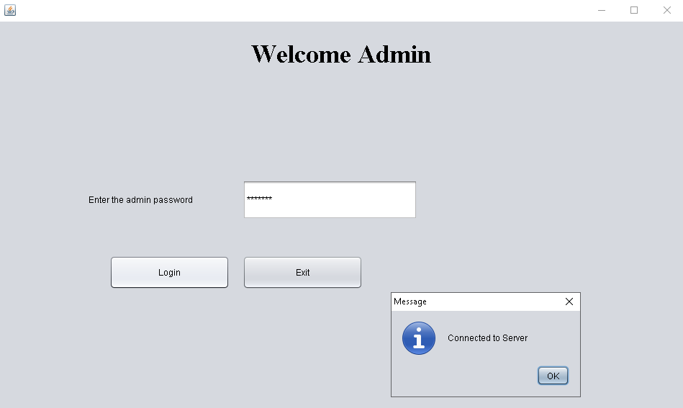

**2. Customers**

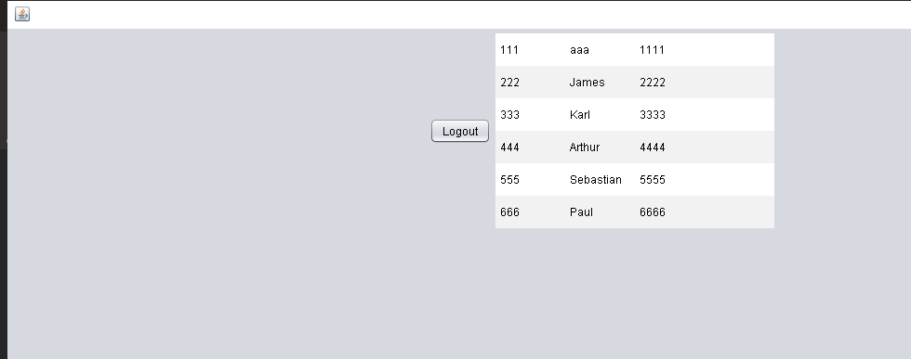

1. **Home**

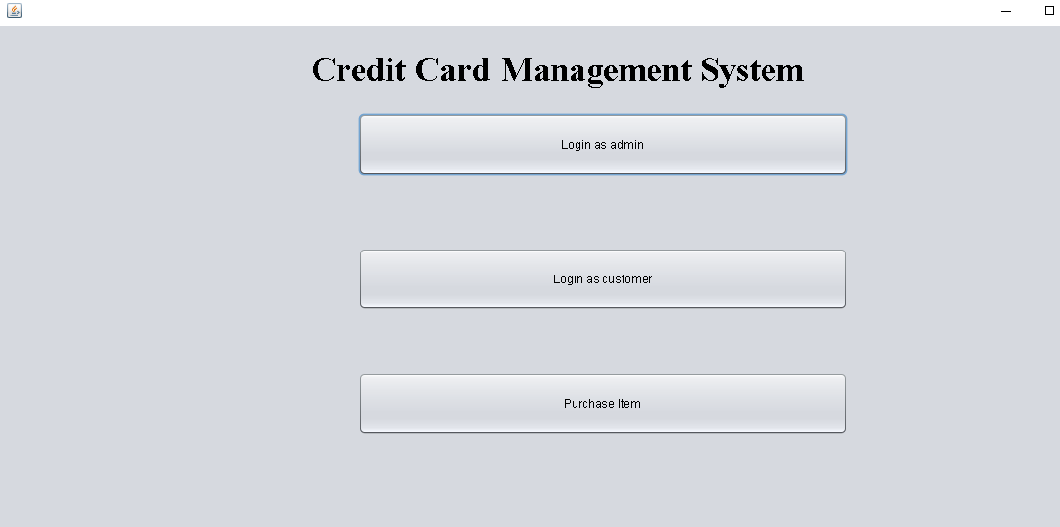

1. **Customer Login**

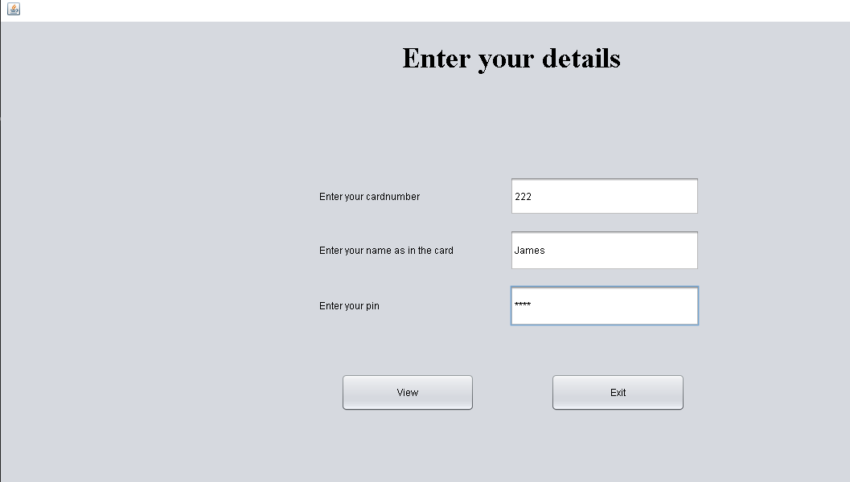

1. **Purchasing Items**

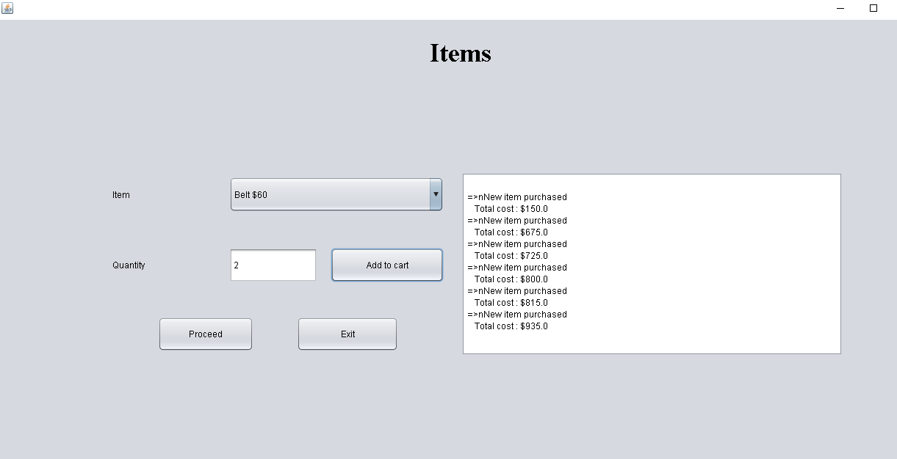

1. **Payment**

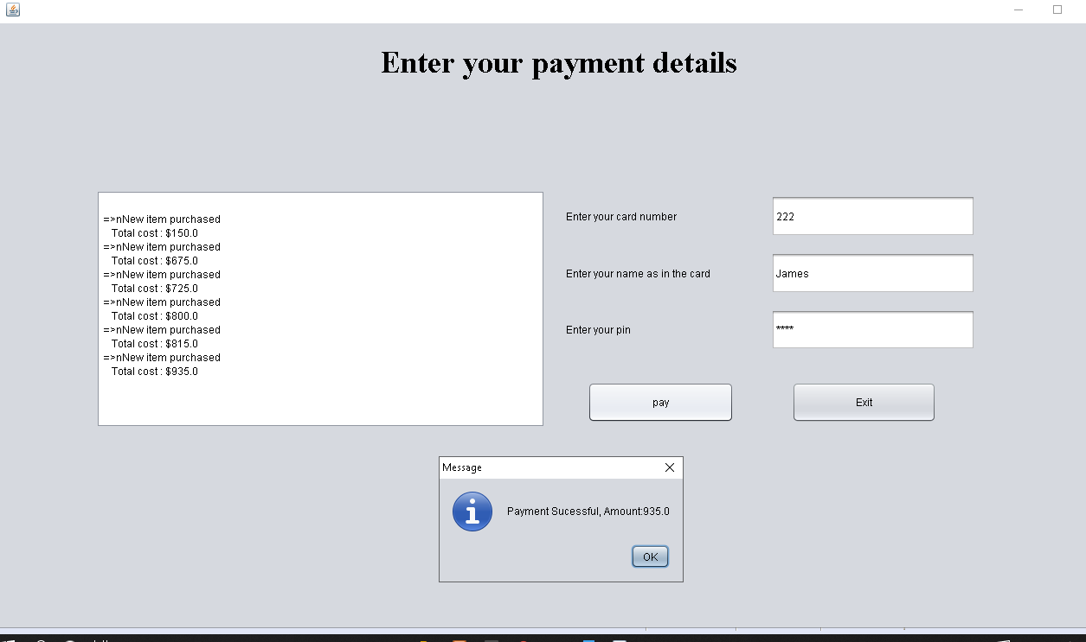

1. **Sql file**

